**The Medieval World View: the Ptolemaic System**

**Table 1.** **Explanation of the Diagram of the Universe, from the Outer Circle to the Center:**

h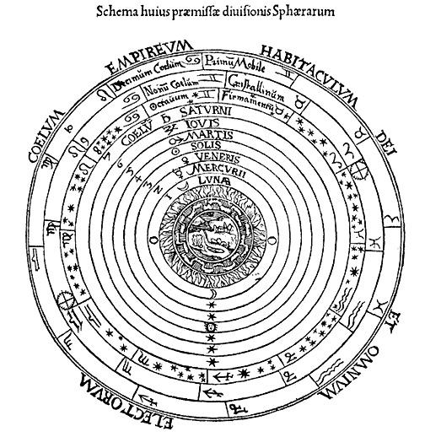

**The Empyreal Heaven, the Habitations of God and of all the Elect. (**Stable, incorruptible, above the realm of time.)

**The Tenth Heaven, the First Mover.** (An envelope containing the universe: clockwise rotation period of 24 hours; the motion is imparted to the 7 planetary spheres.)

**The Ninth Heaven, or Crystalline Sphere.**

**The Eighth Heaven, the Firmament or Sphere of the Fixed Stars.**

**The Sphere of Saturn.** (Counter-clockwise rotation period of approximately 12 years.)

**The Sphere of Jupiter. (“ ” 12 years.)**

**The Sphere of Mars. (“ ” 2 years.)**

**The Sphere of the Sun. (“ ” 1 year.)**

**The Sphere of Venus. (“ ” 224 days.)**

**The Sphere of Mercury. (“ ” 88 days.)**

**The Sphere of the Moon. (“ ” 27.5 days.)**

**The Belt of Fire.**

**The Belt of Air.**

**Earth.** (A stationary globe at the center of the universe, smaller than any planet save the moon. Everything on earth is a corruptible compound of the four elements—namely, fire, air, water, earth.)

**Figure at top:** a pre-Copernican diagram of universe. (Slightly adapted from an image available at http://commons.wikimedia.org/wiki/File:Ptolemaicsystem-small.png.) See also Claudius Ptolemy: The Geography. Ed. Edward Stevenson. New York: Dover, 1991; The Riverside Shakespeare. Boston: Houghton, 1974, and Petrus Apianus, *Cosmographia*, Antwerp, 1574. From Stanford University Libraries. (Thanks to Prof. Vicki Silver of UC Irvine for this guide.)